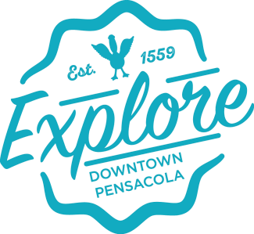

**Downtown Improvement Board Regular Monthly Meeting** Wednesday April 22nd, 2025, 7:30 **AGENDA**

1. Call to Order
   1. Remarks from Chairman
2. Recurring Agenda
   1. Meeting was properly noticed.
   2. *Approval of the proposed meeting agenda for April 22nd, 2025
   3. *Approval of the minutes from the regular meeting of the DIB on April 2nd, 2025
   4. *Approval of the March Financials
3. On-Going Business
   1. PPD Report
   2. Spotless Report
   3. Marketing Report
   4. Palafox Market
4. New Business
   1. Schedule Meeting with Palafox Market Vendors
   2. Foot Traffic Counter Update
   3. Jefferson Alleyway Closure
   4. FooFoo Project Submission
   5. Repast Dinner – 09/07/2025
5. Public Comment
6. Adjournment

Next meeting – May 27th, 2025

(*) = approval item